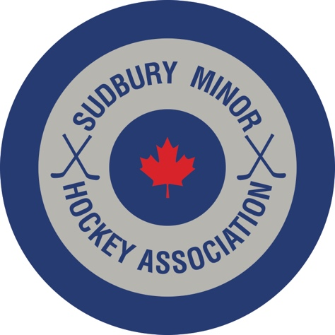

AA and A Coaching Announcement for 2021-2022

The Sudbury Minor Hockey Association Board of Directors is pleased to announce the following coaches for AA and A:

U16 AA: Head Coach – To Be Determined

U15 A: Head Coach – To Be Determined

U14 AA: Head Coach – Neil McLean

U12 AA: Head Coach – Richard Spadafora

U11 AA: Head Coach – Vagelli Sakellaris

U10 AA: Head Coach – Bruno Lafortune

U9 TIER 1 – Damir Brujic

Congratulations to all selected coaches!
The coaches that are ‘To Be Determined’ will be decided once the level of interest at those levels has been determined.

